PRESS RELEASE

ANDRITZ Oy and LUT University conclude significant collaboration agreement

GRAZ, NOVEMBER 11, 2021. ANDRITZ Oy, part of international technology Group ANDRITZ, and LUT University have agreed on extensive collaboration in fiber technology research. The unique corporate collaboration model is a step towards a new way of sharing infrastructures and intensifying joint research work. Extensive collaboration of a high scientific standard between LUT and ANDRITZ Oy aims to meet industry needs and includes the establishment of a modern research center on LUT’s Lahti campus in Southern Finland.

The planned research center and LUT's academic expertise bring added value to ANDRITZ’s own research and innovation. By investing in product development, ANDRITZ aims to strengthen its brand as a forerunner of innovative technologies and an attractive employer. Locating the research center in Lahti, Southern Finland, will enable close collaboration between ANDRITZ and LUT researchers.

Kari Tuominen, President and CEO of ANDRITZ Oy, says: “The modern research center will enable us to study, test and analyse conventional and also new fiber materials in a centralized way. Both LUT and ANDRITZ focus on technology that promotes sustainable development, utilization of side streams, and energy efficiency. LUT educates a highly skilled workforce, and we offer them thesis projects and jobs.”

Riina Salmimies, Dean of LUT University, comments: “This collaboration will enable us to build laboratory facilities on LUT's Lahti campus on a wider scale than we had anticipated. In practice, we will expand the campus laboratories by nearly a thousand square meters, acquire a wider range of equipment, and recruit new staff to the Lahti location.”

The laboratories are currently being designed, and research activities will start in September 2022. Salmimies is especially glad that, from the very beginning, the laboratory work in Lahti will be strongly driven by the needs of the industry, such as the growing bioeconomy cluster in the area.

ANDRITZ Oy and LUT have a strong global and international perspective in common.
In addition to the collaboration agreement now concluded, the two parties intend to expand their work beyond fiber research. “This is a completely new approach to collaboration. It remains to be seen what opportunities it will open up in the coming years,” according to Kari Tuominen and Riina Salmimies.

The aim is to widen ANDRITZ’s strong research resources, create innovations, and achieve technological leadership in the global market.

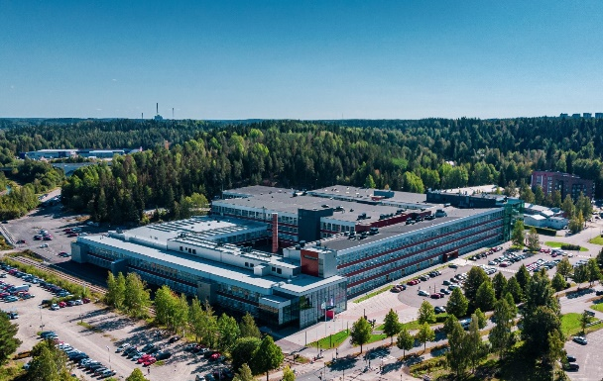
◄ The collaboration will enable laboratory facilities to be built on LUT’s Lahti campus.

PRESS RELEASE AND PHOTO AVAILABLE FOR DOWNLOAD
Press release and photos are available for download at andritz.com/news. The photo may be published free of charge if the source is stated: “Photo: LUT”.

FOR FURTHER INFORMATION, PLEASE CONTACT
Dr. Michael Buchbauer
Head of Corporate Communications
michael.buchbauer@andritz.com
andritz.com

ANDRITZ GROUP
International technology group ANDRITZ offers a broad portfolio of innovative plants, equipment, systems and services for the pulp and paper industry, the hydropower sector, the metals processing and forming industry, pumps, solid/liquid separation in the municipal and industrial sectors, as well as animal feed and biomass pelleting. Plants for power generation, flue gas cleaning, recycling, and the production of nonwovens and panelboard complete the global product and service offering. Innovative products and services in the industrial digitalization sector are offered under the brand name Metris and help customers to make their plants more user-friendly, efficient and profitable. The publicly listed group has around 26,700 employees and more than 280 locations in over 40 countries.

ANDRITZ PULP & PAPER
ANDRITZ Pulp & Paper provides equipment, systems, complete plants and services for the production of all types of pulp, paper, board and tissue. The technologies and services focus on maximum utilization of raw materials, increased production efficiency and sustainability as well as lower overall operating costs. Boilers for power generation, flue gas cleaning systems, plants for the production of nonwovens and panelboard (MDF), as well as recycling and shredding solutions for various waste materials also form a part of this business area. State-of-the-art IIoT technologies as part of Metris digitalization solutions complete the comprehensive product offering.

LUT University
Clean energy, water and air are life-giving resources for which LUT University seeks new solutions with its expertise in technology and business. LUT University helps society and businesses with their sustainable renewal efforts. Its international community consists of 6,500 members. LUT’s campuses are in Lappeenranta and Lahti, Finland. LUT is one of the world’s top 10 universities for climate action.

